14.69: a) Let the total volume be V; neglecting the density of the air, the buoyant force in terms of the weight is
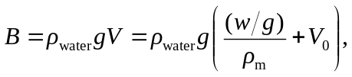
or
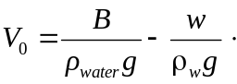
b)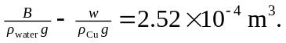Since the total volume of the casting is 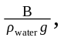the cavities are 12.4% of the total volume.

